Reasoning 2022

**1.**

**a)**

P1(4, 2) = 4*3*2 = 24

Since 4 ≠ 2, by (R2) : P1(4,2) = 4 * P1(3, 2)

Since 3 ≠ 2, by (R2) : P1 (3,2) = 3 * P1 (2, 2)

By (R1): P1(2,2) = 2

Therefore, P1(4,2) = 4 * P1(3,2) = 4 * 3 * P1(2,2) = 4 * 3 * 2= 24

Because 2 < 4 and by decrementing 2, we will never hit the base case where 4 = 4

P2(4, 2, 1) = 4*4*4*(1*2*3) = 384

Since 4 ≠ 2, by (R4) : P2(4,2,1) = 4 * P2(4,3,2)

Since 4 ≠ 3, by (R4) : P2(4,3,2) = 4 * P2(4,4,6)

By (R3) : P2(4,4,6) = 4 * 6 = 24

Therefore, P2(4,2,1) = 4 * 4 * 24 = 384

P2(2, 4, 1) does not terminate.

Because 4 > 2 and by increasing 4, we will never get 4 to hit the base case where it equals to 2

**b)** WTP: ∀k : ℕ. ∀m, n : ℤ [m – n = k → ∃z : Z [P1(m, n) = z]]

**Inductive Principle:**

∀m, n : ℤ [m – n = 0 → ∃z : Z [P1(m, n) = z]] (base case)

∧

∀k : ℕ [ ∀m, n : ℤ [m – n = k → ∃z : Z [P1(m, n) = z]] (IH)

→

∀m, n : ℤ [m – n = k + 1 → ∃z : Z [P1(m, n) = z]]]

→

∀k : ℕ. ∀m, n : ℤ [m – n = k → ∃z : Z [P1(m, n) = z]]

**Base Case:**

(1) Take arbitrary m, n : ℤ.

(2) Assume m – n = 0

(3) m = n From (2)

(4) P1(m, n) = m From (R1) and (3)

(5) ∃z : Z [P1(m, n) = z] From (4)

(6) m – n = 0 → ∃z : Z [P1(m, n) = z] From (2) and (5)

(7) ∀m, n : ℤ [m – n = 0 → ∃z : Z [P1(m, n) = z]] From (1) and (6)

**Inductive Step:**

(1) Take arbitrary k : ℕ

(IH) Assume ∀m, n : ℤ [m – n = k → ∃z : Z [P1(m, n) = z]]

(2) Take arbitrary m, n : ℤ

(3) Assume m – n = k + 1

(4) m ≠ n From (3)

(5) P1(m, n) = m * P1(m – 1, n) From (R2) and (4)

(6) (m – 1) – n = k From (3)

(7) ∃z : Z [P1(m – 1, n) = z] From (IH)

(8) Let o : Z such that P1(m – 1, n) = o From (7)

(9) P1(m, n) = m * o From (5) and (8)

(10) ∃z : Z [P1(m, n) = z] From (9)

(11) m – n = k + 1 → ∃z : Z [P1(m, n) = z] From (3) and (10)

(12) ∀m, n : ℤ [m – n = k + 1 → ∃z : Z [P1(m, n) = z] From (2) and (11)

So, from (Inductive Principle), (Base Case) and (Inductive Step):

∀k : ℕ. ∀m, n : ℤ [m – n = k → ∃z : Z [P1(m, n) = z]]

**c)**

∀ m,n: Z [m ≥ n → [∃z: Z. P1(m,n) = z]]

∀ m,n: Z [m – n ≥ 0 → [∃z: Z. P1(m,n) = z]] [by algebra]

∀ m,n: Z [∀k [m – n = k] → [∃z: Z. P1(m,n) = z]] [by idea of ≥]

∀ k: N, ∀ m,n: Z [m – n = k → [∃z: Z. P1(m,n) = z]] [same thing]

True as proven in (A)

d)

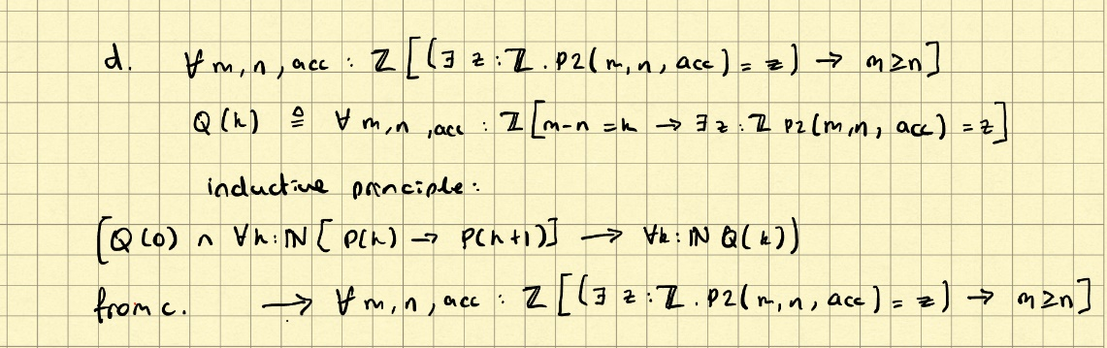

∀m, n, acc : ℤ [ ∃z : ℤ . [ P2(m, n, acc) = z) ] → m ≥ n ]

Q(k) ≜ ∀m, n, acc : ℤ [ ∃z : ℤ . [ P2(m, n, acc) = z ] → m – n = k ]

Inductive principle:

[Q(0) ∧ ∀k : ℕ . [ Q(k) → Q(k + 1) ] → ∀k : ℕ . [ Q(k) ] ]

From c: → ∀m, n, acc : ℤ [ (∃z : ℤ . [P2(m, n, acc) = z] → m ≥ n ) ]

ei) (NShape (NShape LShape LShape) LShape, [‘c’, ‘r’, ‘y’])

(((Daniel) (bracket enthusiast))(😊)) ((NShape (NShape (LShape) (LShape)) LShape), “cry”)

eii) (( Node ( Leaf ‘b’ ) ( Node ( Leaf ‘y’ ) ( Leaf ‘e’ ))), [] )

f) **∀t : Tree . [ zip (split t) = (t, []) ]** <- this is the answer (everything below is the proof of it which isn’t needed in the exam) brop

Base case: prove for leaf

∀c : Char . [ zip (split (Leaf c)) = (c, []) ]

Inductive step: prove for node, given that if it works for a leaf, as nodes are made of ~~leafs~~ leaves (fuck Canadians), it must hold for all nodes.



“Where rest of paper”